**Windows Lab 3 Introduction to MS-DOS**

**SARA HACHECHE 5672186**

## **Objective:** Using the command line interface of an Operating System

At the end of this lab, you will be able to:

* Access a command line interface (CLI)
* Use the Help facility in MS-DOS
* Display the list of files/folders in a directory using DIR command
* Create a new folder using MD command
* Use the CD command and its various switches
* Use the RD command to remove folders

# Instructions

**It is important that you complete this and other lab sheets even though you feel you are familiar with the DOS Prompt.**

**Use the Help option in MS-DOS and the internet to find out information on doing the following tasks.**

**Complete each task in this document and record the answers (in your own words).**

**This completed sheet will then be useful for later use.**

**Introduction**

MS-DOS is a "Disk Operating System". That means it is simply "a System for Operating the Disks". It enables the user to organise data files, load and execute (run) programs and control the input and output devices attached to the computer. MS-DOS is a 16 bit, single-user operating system that does not support multi-tasking.

When compared to graphical interfaces such as Windows, it's also not particularly user-friendly and has faded in significance. What MS-DOS is good for is to introduce you to operating a PC/Computer or Server at a Command Line. Windows 10 includes a DOS-like command line interface which we will use. While DOS is increasingly not being used in the running of 32-bit and 64-bit applications, it is still important to know DOS commands.

You can read more about DOS at the following website addresses:

* <https://www.c3scripts.com/tutorials/msdos/>
* <https://youtu.be/kl9u8owo0oM>

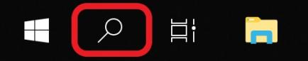

**You can start command prompt a few different ways:**

1. Click on the Search Icon in the tray and type in **Command** and enter (below)
2. Go to Start -> Windows System -> Command Prompt (below)

You should now see an image similar to that below

**Task 1:** What is your ***current working directory***? C:\Users\hache

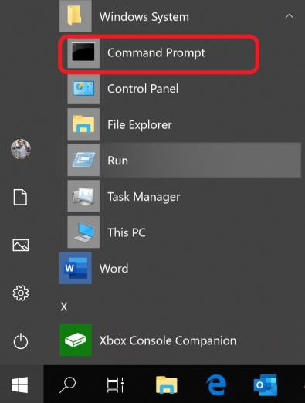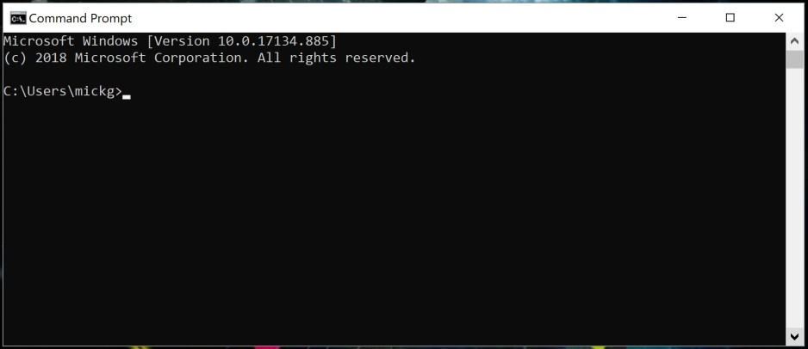

* In the image on the previous page, the answer is **C:\Users\mickg>**
* Your current location is the **path** before the **>** symbol.

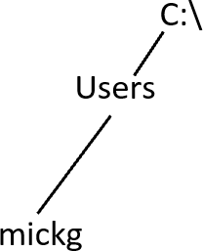

**Your hierarchical path:**

**C:\**

**Users**

**hache**

**Example:**

In the box provided below, draw a diagram representing the hierarchial path to your location.

**Task 2:** Type in “help” at the command prompt. This provides a list of the available commands.

**Task 3:** Check out the following commands and write down what they do.

* DIR Displays a list of files and subdirectories in a directory.
* CD or CHDIR Displays the name of or changes the current directory.

* MD or MKDIR Creates a directory.

Nearly all commands use the same kind of syntax, the command name followed by one or more arguments.

* You can get information about how to use the command by using the command name followed by **/?**
  + For example **md /?** Will provide you with the help entry for the **md** command

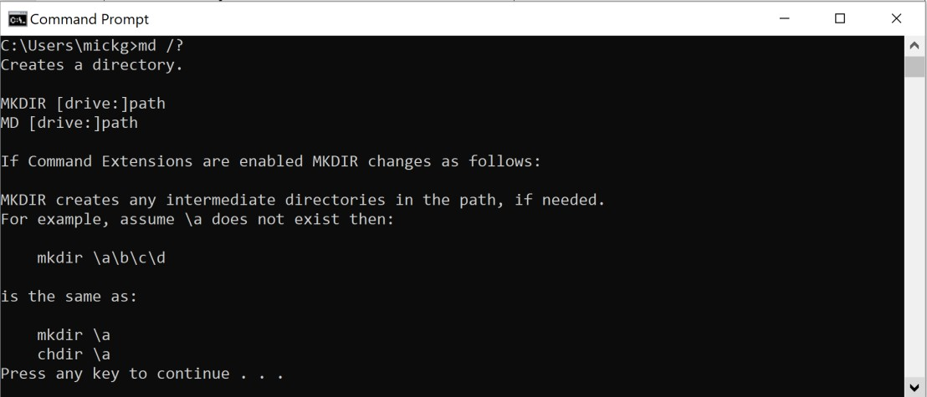

**Task 4: Creating a directory**

You are going to create the following directory structure on your G: Drive

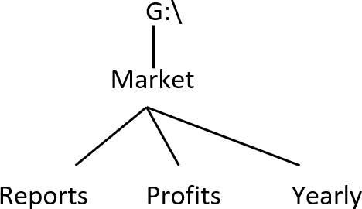

To do this, complete the following steps:

1. Change directory to the root of your G drive.
   * To do this, type **g:** at the command prompt
2. On the next line, type: **cd \**
   * This will bring you to the root folder of the drive
3. Create a directory called **Market** in the root of your G drive.
   * To do this, type **mkdir Market**

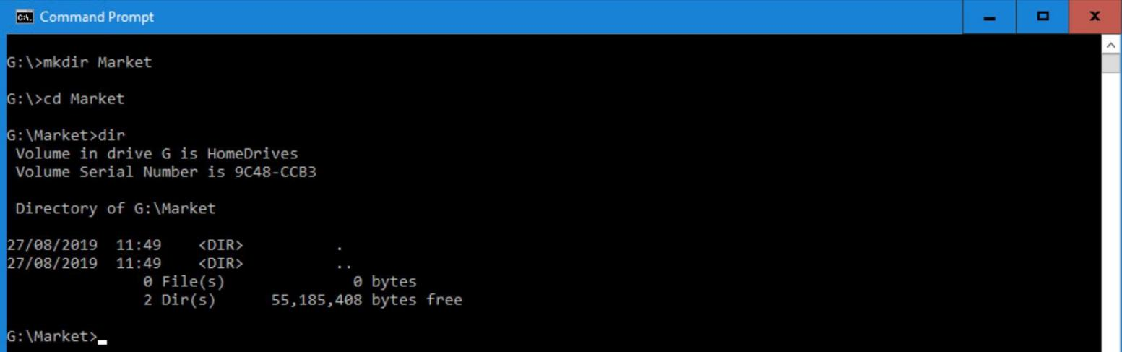

**Task 5:**

Use the **md** command [make directory] to create these directories also.

**md g:\Market\Reports md g:\Market\Profits md g:\Market\Yearly**

These are called **absolute** or **full paths.**

They start at the root of the drive (G: in this case)

**g:\Market\Yearly**

**Task 6:**

Create a new folder called **Personal** in the **Market** folder. There should be four folders in the **Market** folder now.

**Task 7: Navigating through the directories.**

* Use the **cd** [change directory] command to move within the directories you have created.
  + Navigate yourself around your directory structure using these commands.

**cd \ : change directly to root folder**

**cd .. : change to parent folder (one level up) cd** followed by folder name **: change to given folder name (subfolder)**

Firstly change to the root of the G: drive.

This will have the effect of changing you **directly** to the root of the G: drive from where you are. To change down a directory to the **Market** folder from the root directory, type **cd Market**

* What does the command prompt look like now? C:\Market> cd Market
  + It should look like **G:\Market>**

This indicates that any command typed at this prompt will now be effective from that folder.

**Task 8:**

1. Change back to the root folder
   * What command did you use? Cd ..
2. Change to the new folder called **Personal**
   * What command did you use? Cd Personel
3. Type **cd \**
   * What does this command do? Change directory to root folder
4. Change to the **Market** folder
   * What command did you use? Cd ..
5. Change to the **Yearly** folder
   * What command did you use? cd Yearly
6. Type **cd ..**
   * What does this command do? change to parent folder
7. Change back to root folder.
8. Type **cd Market\Personal**
   * What does this command do? It’s change the current location to c:\Market\Personal>

All these exercises use **relative paths**, as they start relative to your current location. Here are some shortcuts

and typical paths.

***..***

*(dot dot)*

: this refers to one level up from current location

***Market\Personal***

: two levels down from current location (via market and personal subfolders)

***\***

*(slash)*

: directly to root from current location

**Task 9:**

Using the command line, add the following extra folders (Photos and Letters):

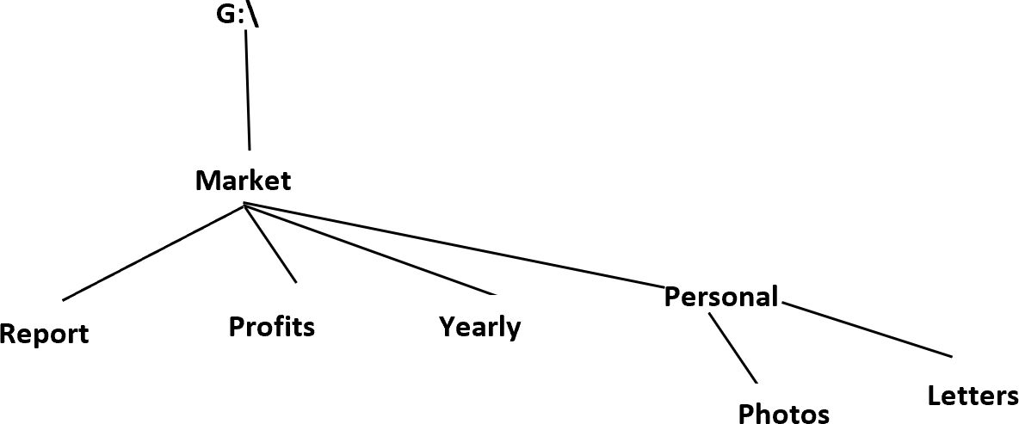

What DOS command(s) did you use to do this?

* C:\Users\hache>cd /
* C:\>CD MARKET
* C:\Market>CD Personal
* C:\Market\Personal>Md photos
* C:\Market\Personal> Md letters

**Task 10:**

The **DIR** command, use help to find the purpose of the **DIR** command, write a brief explanation here:

Its used to display a list of the files and subfolders contained in a folder, For each file or directory listed, the command will,

.

show the date and time the item was last changed, if the item is a folder (labeled with DIR) or file, the size of the file if applicable.

**Task 11:**

Change to the **Market** folder on your **G:** drive.

1. Type **dir ,** What does this command do? Displays files with specified attributes.
2. Type **dir /w ,** What is the effect of the /w switch? - **Displays only filenames and directory names in a five-wide display format**.
3. Type **dir /s ,** What is the effect of the /s switch? Displays files in specified directory and all subdirectories.
4. Type **dir /p ,** What is the effect of the /p switch? Pauses after each screenful of information
5. Type **dir /w/s ,** What is the effect of the two switches? instructs it to go deeper than the root of c: and instead, search for files like this in every folder, as deep as the folders go.

**Task 12: Changing Drives**

To change to another **drive** you must type in the drive letter followed by a full colon. For example, to change to the M drive type:

**m:**

Your DOS prompt should have changed to **M:\>** you can now browse the directory structure on the M drive.

**Change from your current location to the C: drive:**

* + What command did you use? Cd/..
  + What is the prompt now? C:\>
  + Change to your exam drive (M). What command did you use? In my computer i don’t have drive M i try with drive D for USB i put this command :C:\>D: //
  + Change back to the G drive : D:\>C: //

**Question:** Typing the command **cd c:\** doesn’t work to change drive!

Why? Because this command is used for change the directory in the same drive

**Task 13: Remove a directory**

* + Remove the directory **Photos**, what command did you use? c:\Market\Personal>rd Photos
  + Remove the directory **Personal**.
    - This doesn’t work as can’t remove a directory that contains files/folder.
    - Will need to use a **switch** with **rd** command.
      * A switch is an extra instruction that you pass with the command, there are many switches
      * Use help to find the correct switch first, then ask your Lab Tutor if you get stuck.
  + Write the correct command rd /S/Q Personal

**Task 14:**

Use the inbuilt help function to get information on the following commands.

|  |  |
| --- | --- |
| **Command** | **Write down what each command does and give an example of its use** |
| **CLS** | C:\Market\Personal>cls/?  Clears the screen.  CLS  C:\Market\Personal>cls |
| **RD** | Removes (deletes) a directory.  C:\>md test_rd_command  C:\>cd test_rd_command  C:\test_rd_command>md test.txt  C:\test_rd_command>cd..  C:\>rd /S/Q test_rd_command |
| **COPY** | Copies one or more files to another location.  C:\Market>copy Personal companyacount  Personal\cls  Personal\md  Personal\rd  1 file(s) copied. |
| **MOVE** | Moves files and renames files and directories.  C:\Market>move yearly companyacount  Overwrite C:\Market\companyacount? (Yes/No/All): y  1 dir(s) moved. |
| **RENAME (REN)** | Renames a file or files.  C:\Market>rename companyacount mycompany |
| **TIME** | Displays or sets the system time.  :\>TIME  The current time is: 22:36:59.72 |
| **VER** | Displays the Windows version.  C:\>VER  Microsoft Windows [Version 10.0.19044.2604] |
| **DATE** | Displays or sets the date.  C:\>DATE  The current date is: 2023-02-25  Enter the new date: (yy-mm-dd) |
| **TYPE** | Displays the contents of a text file or files.  Append output to an existing file:  C:\Users\hache>TYPE test.txt >> sara.txt |

**End of Windows Lab 3**

**Page left intentionally blank for notes**